**E.T360 DOCUMENTATION**



**SUMMARY OF DOCUMENTATION**

* USER MANUAL (PHOTO OF PAGES, WHAT EACH PAGE DOES)
* TECHNICAL CODE OF EACH PAGE SUMMARIZED
* EXPLANATION OF PROPERTIES OF CSS USED
* EXPLANATION OF JAVASCRIPT FUNCTIOSN USED IN WEBSITE
* 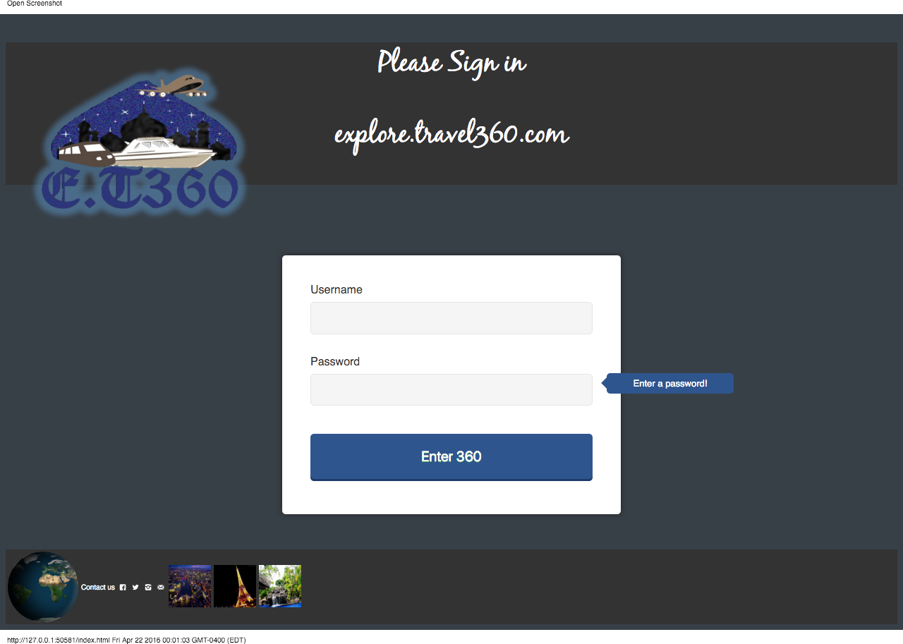Once the user enters the website, the following login page will be displayed.

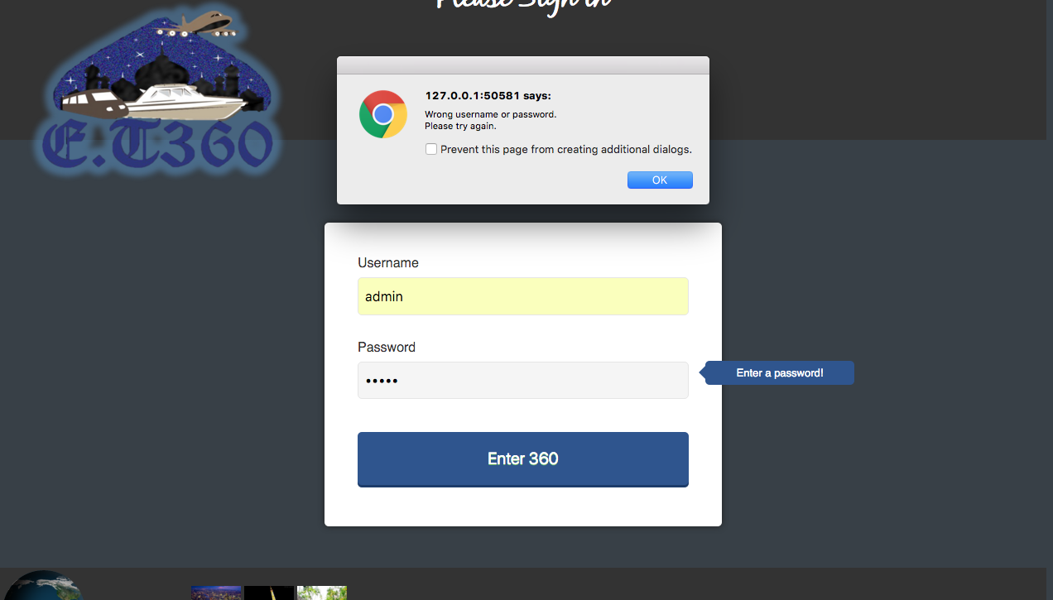

* If the user enters a username and/or password other then admin/1234, an error will appear.
* This travel agency website consists of eight major pages.
* The navigation bar can direct the user to the desired pages.
* The pages are as follows: Flights, Cruises, Hotels, Hot Deals, Explore, About, Contact & Members
* 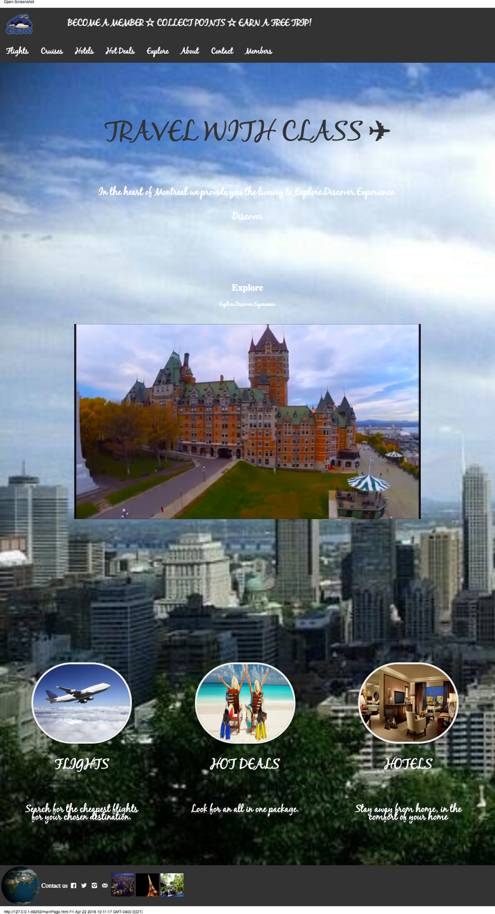The main page will appears as show in the following picture;
* **First Page: Flight Search**

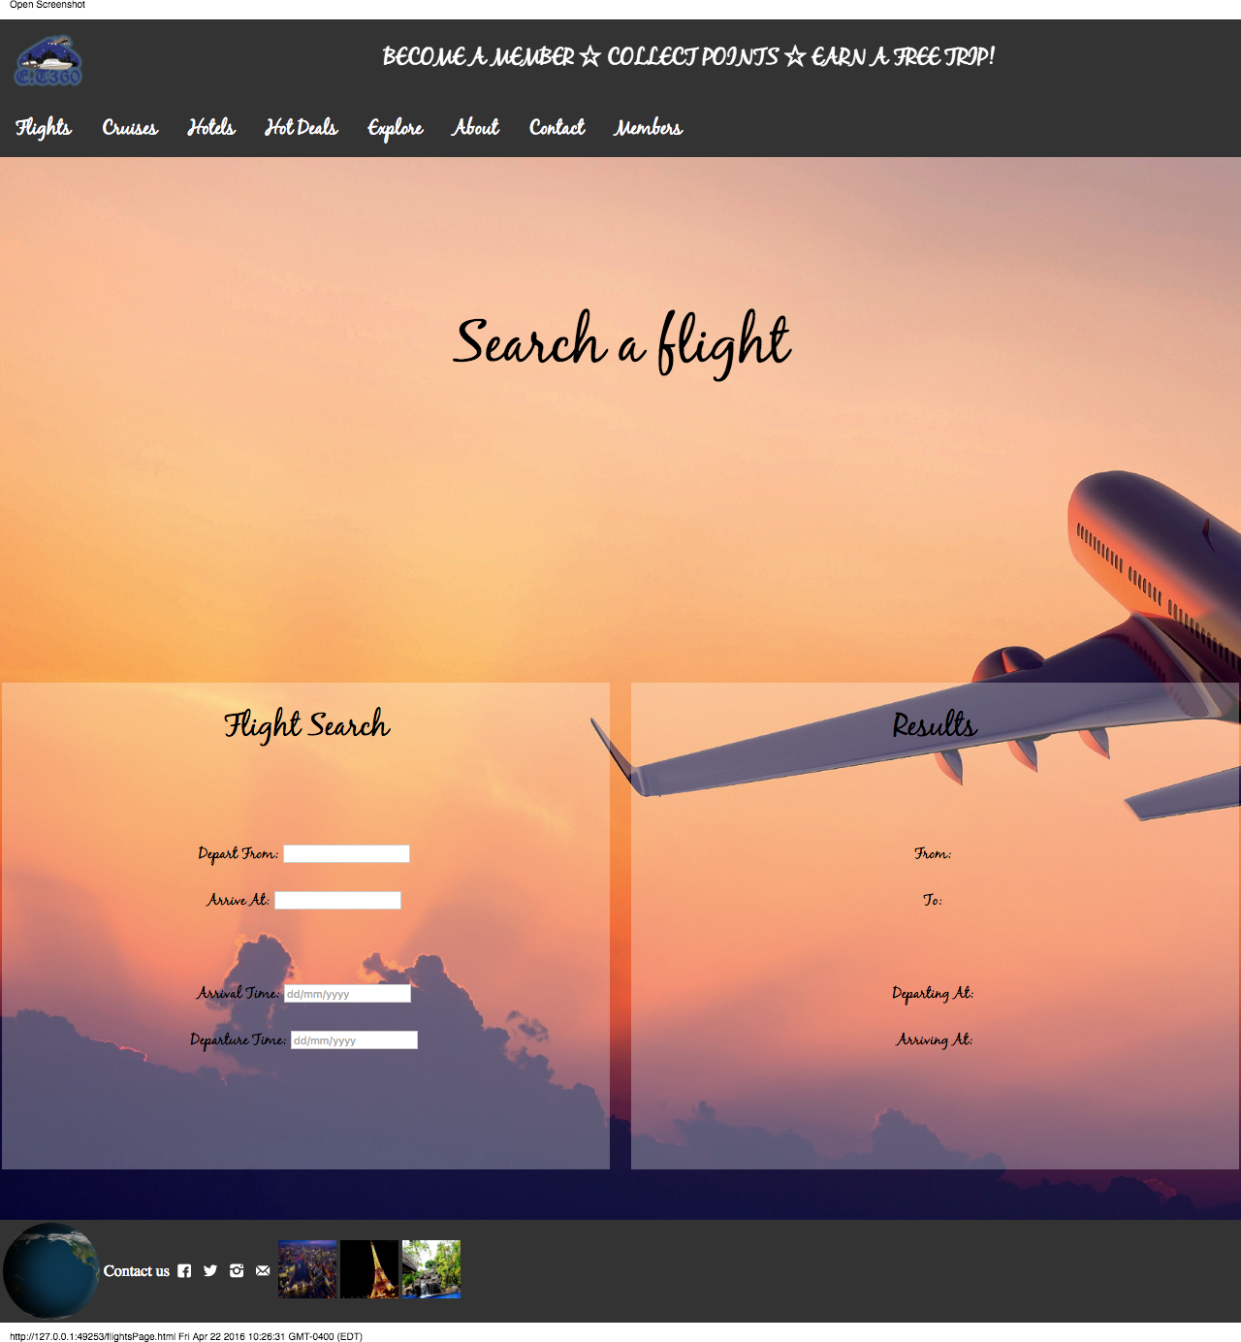

* **Second Page: Cruise Package selection**

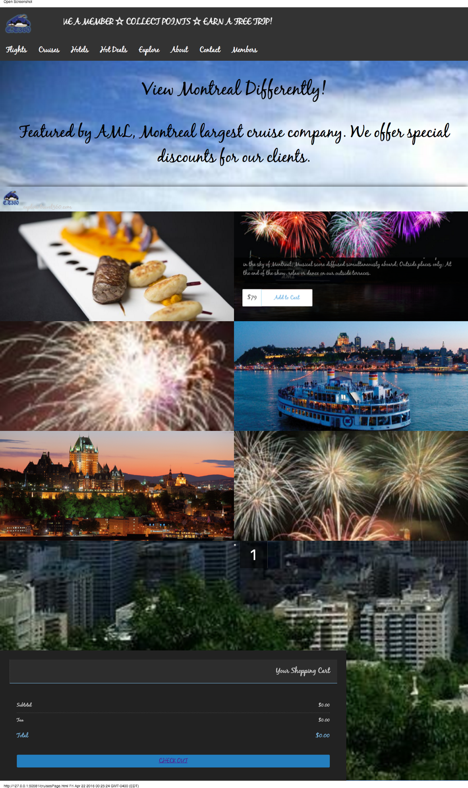

* **Third Page: Hot Deals**

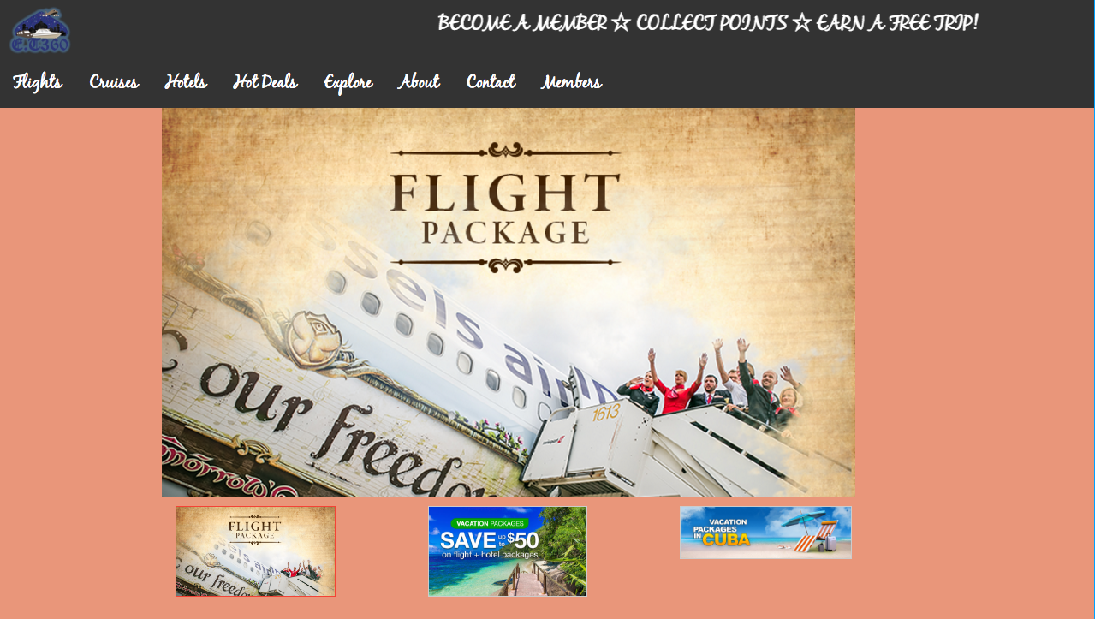

* 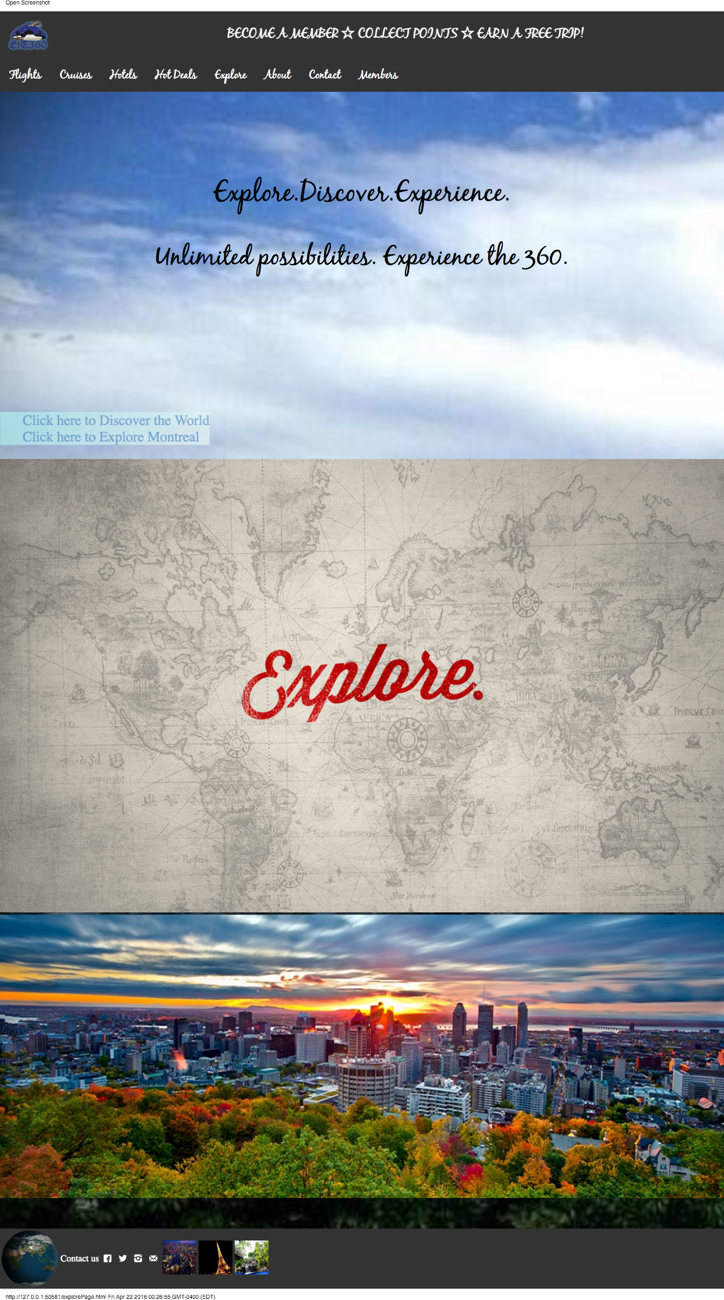**Forth Page: Explore Page**
* **If the user clicks on Discover the world, it will lead them to the explore image. If the explore image is clicked the user will see the following page.**
* 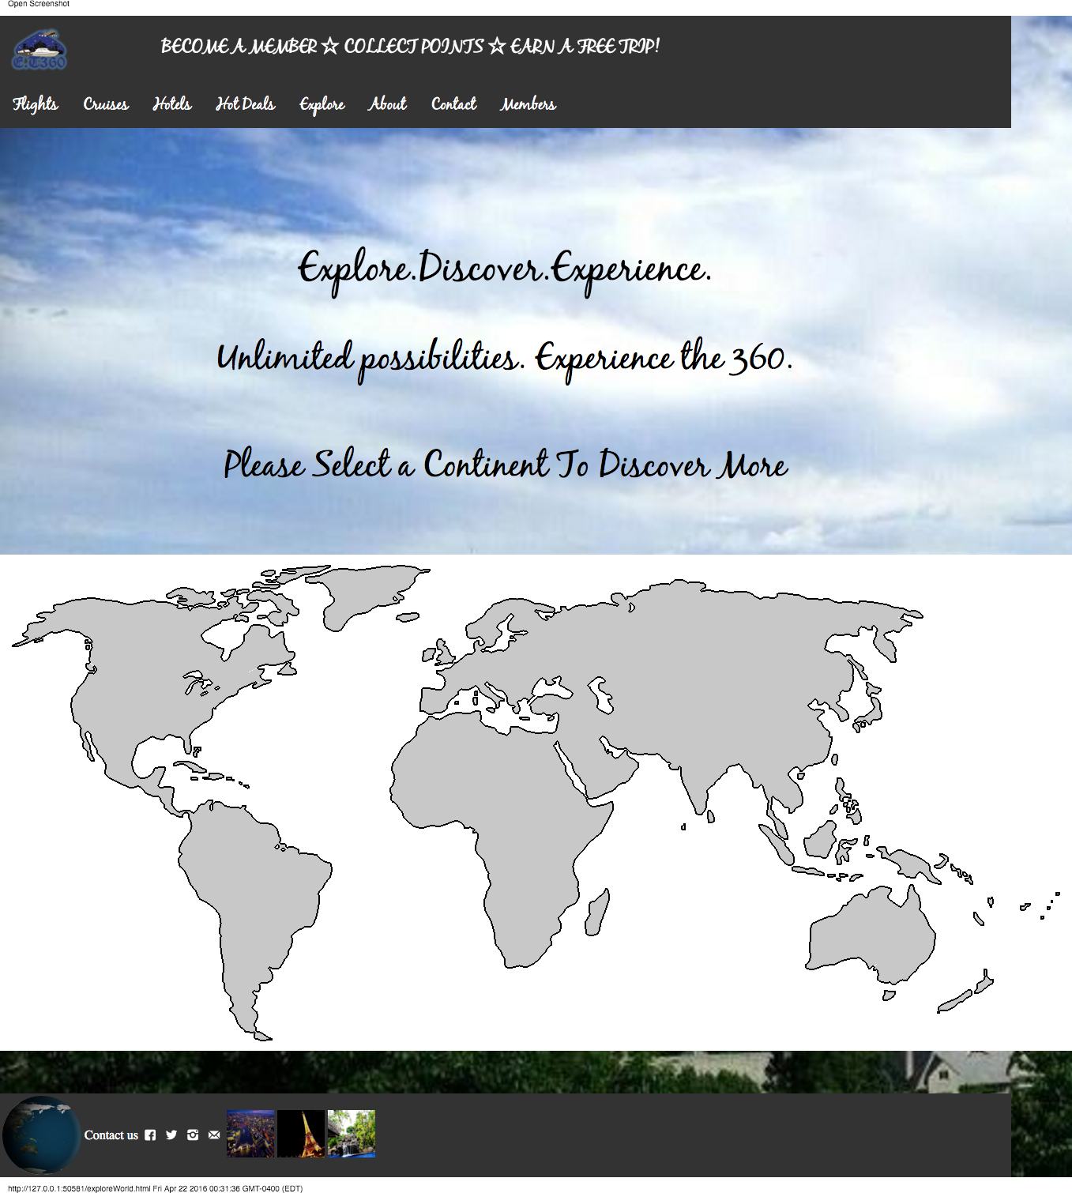**Where the user can select a continent.**
* **The following page will be redirected if the continent of North America is selected.**

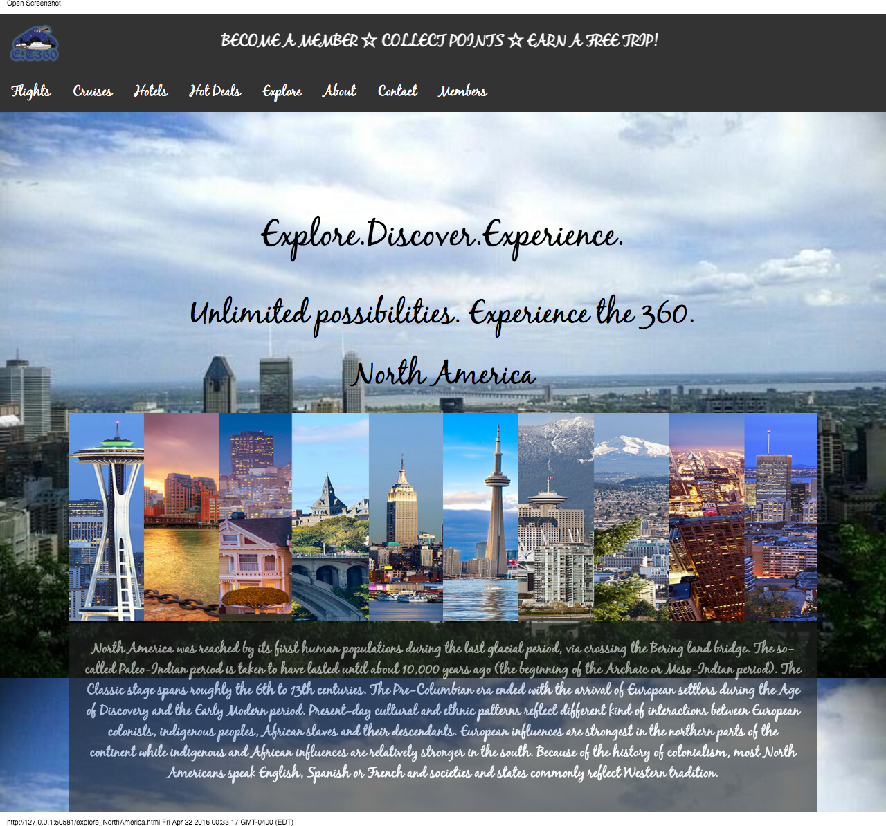

* **The following page will be redirected if the continent of Central America is selected.**

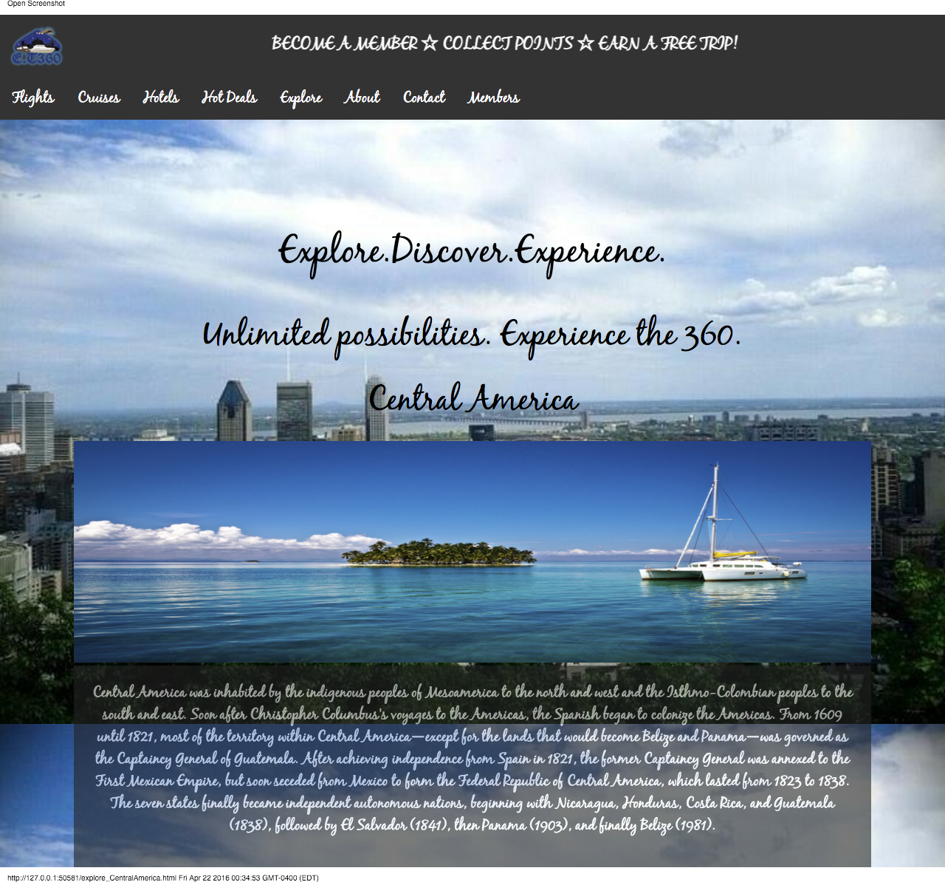

* 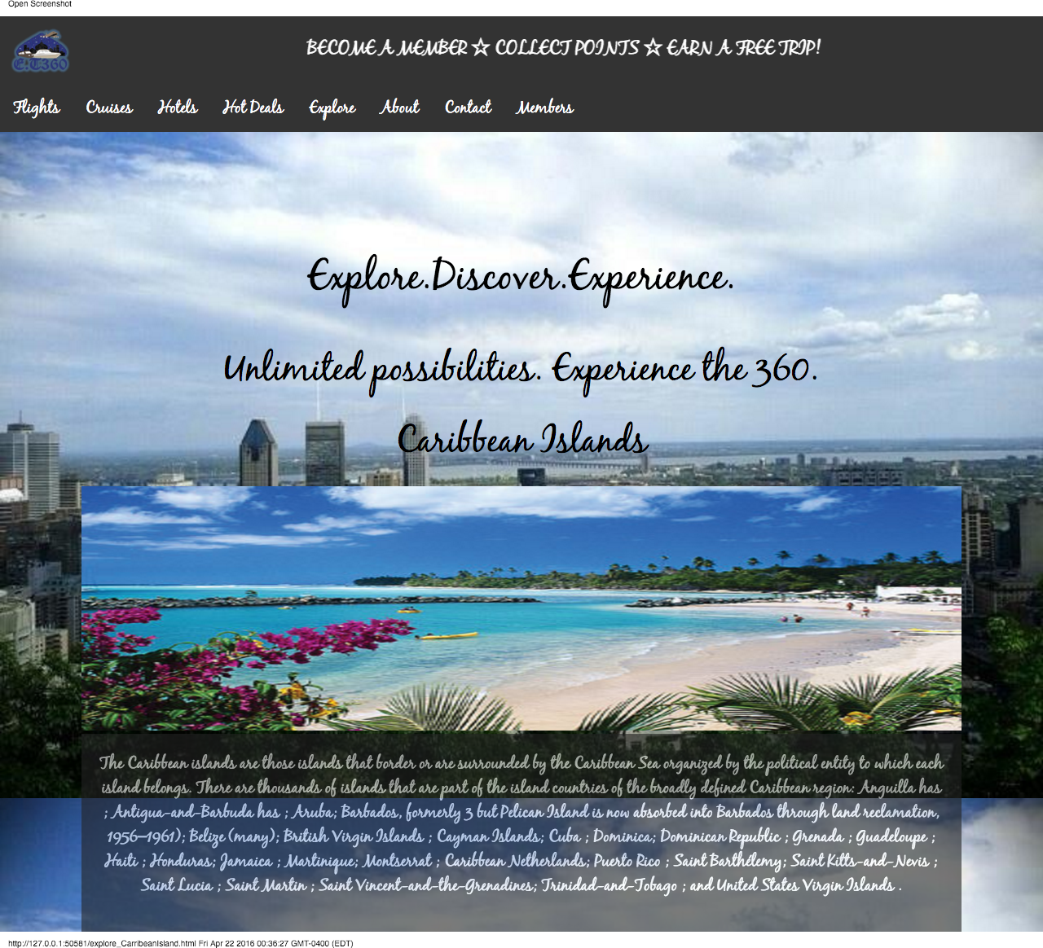**The following page will be redirected if the Caribbean Island is selected.**

* 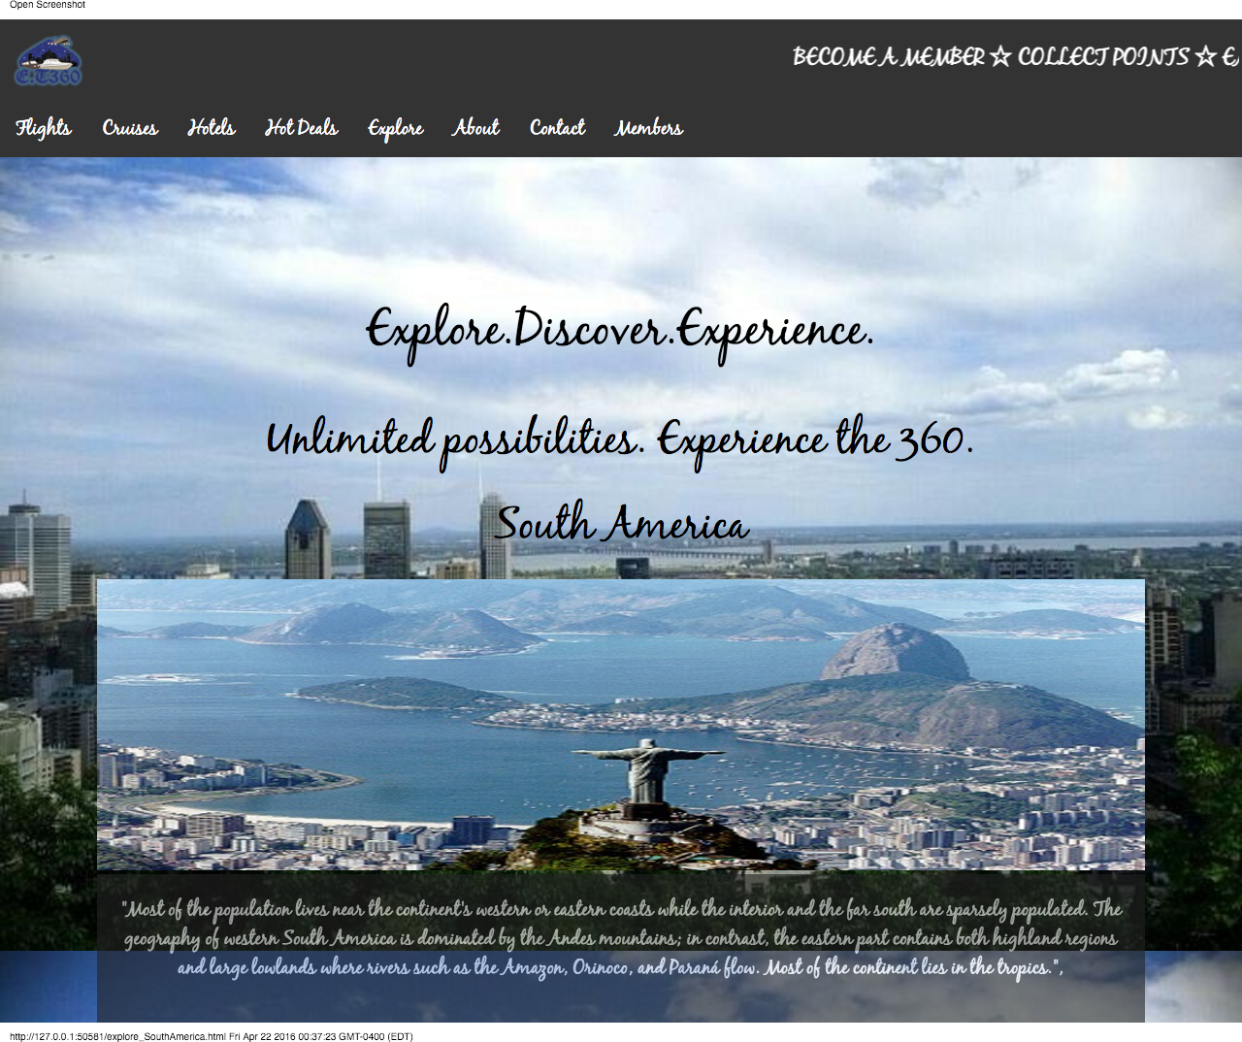**The following page will be redirected if the continent of South America is selected.**
* **The following page will be redirected if the continent of Europe is selected.**

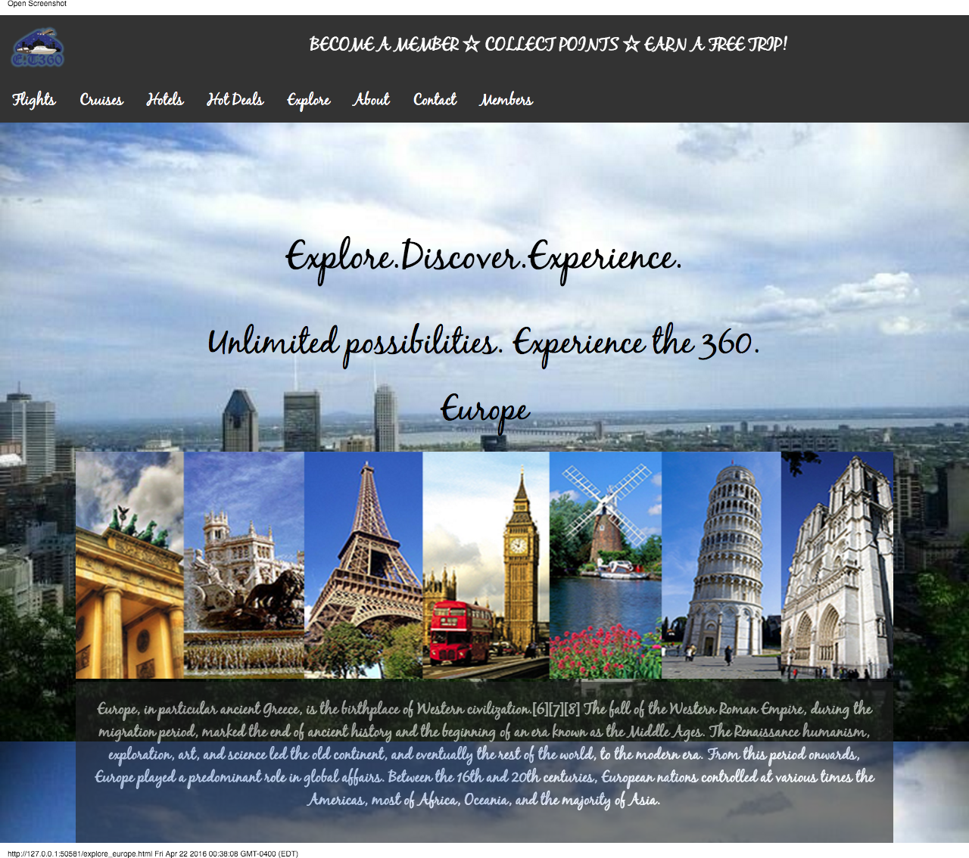

* **The following page will be redirected if Middle East is selected.**

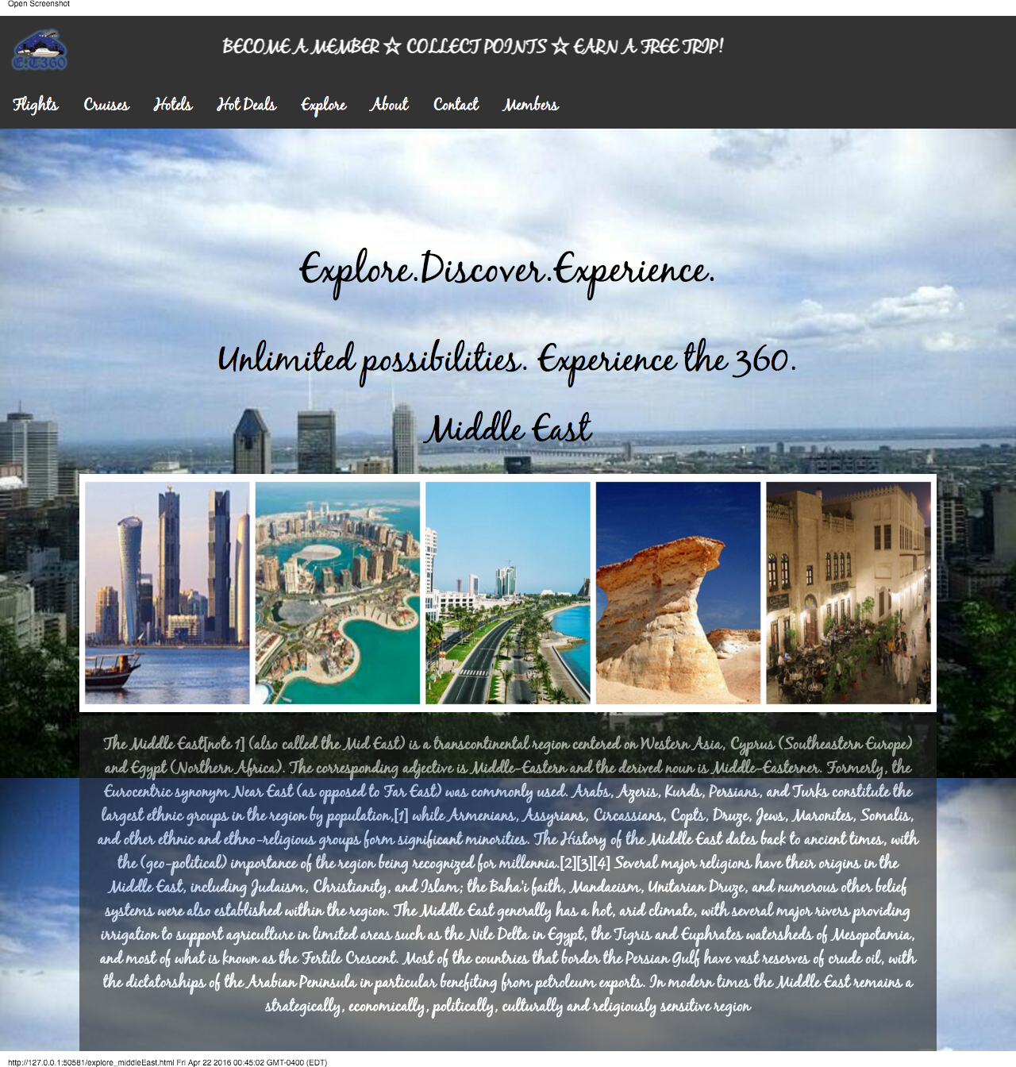

* 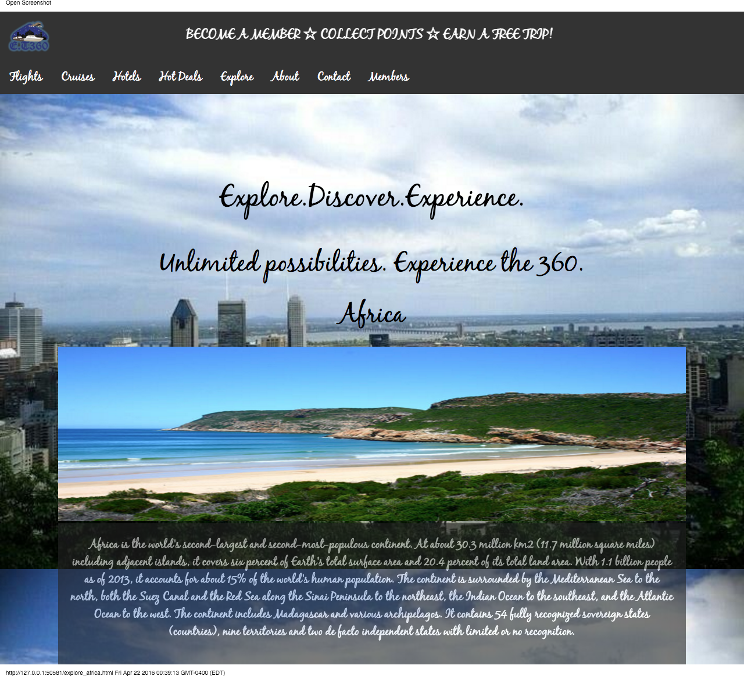**The following page will be redirected if the continent of Africa is selected.**
* 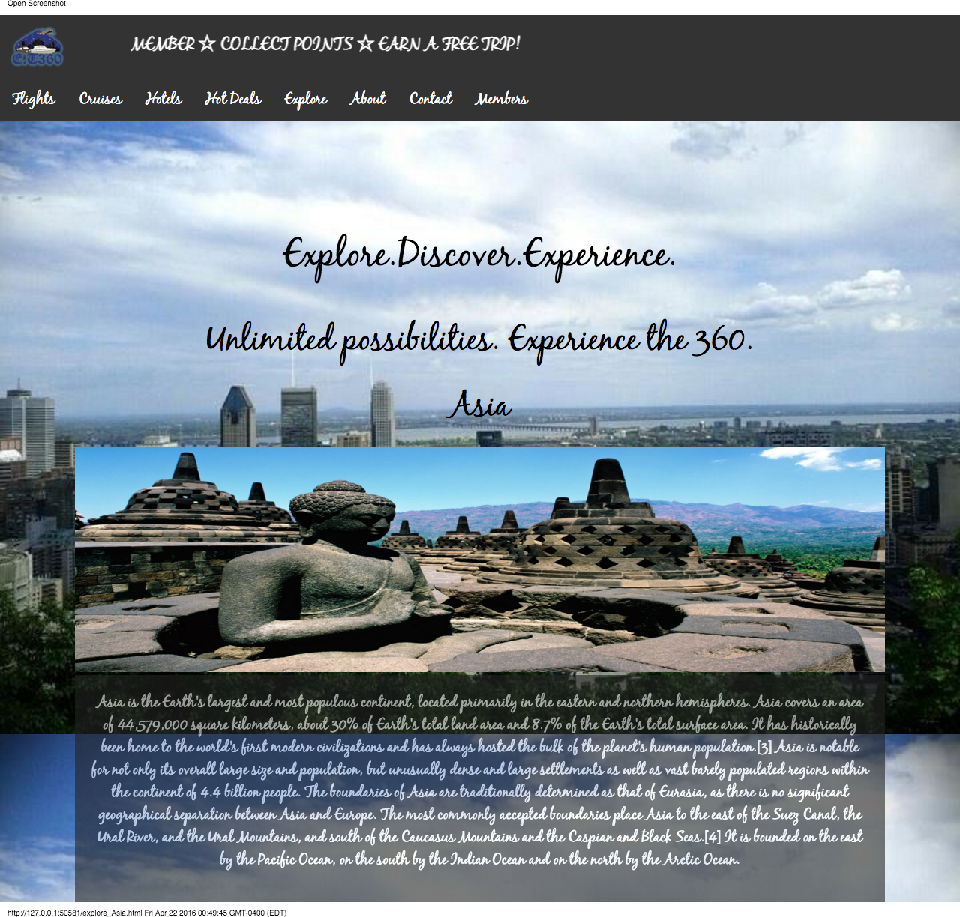**The following page will be redirected if the continent of Asia is selected.**
* **The following page will be redirected if the continent of Australia is selected.**

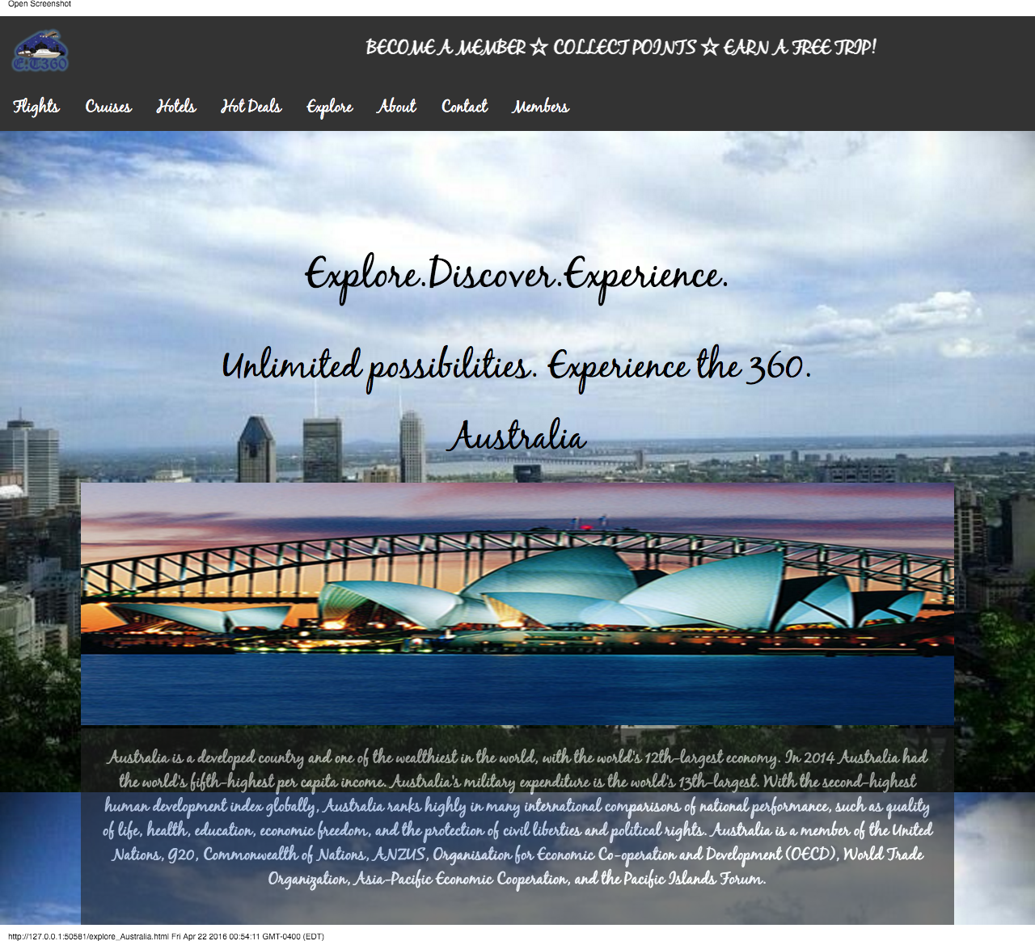

* **The following page will be redirected if from the explore page, the user clicks to discover Montreal.**
* **The user can search a region within Montreal. Ex: Montreal west, Montreal or Montreal East in the Search bar.**
* **According to the search a new page will be redirected.**

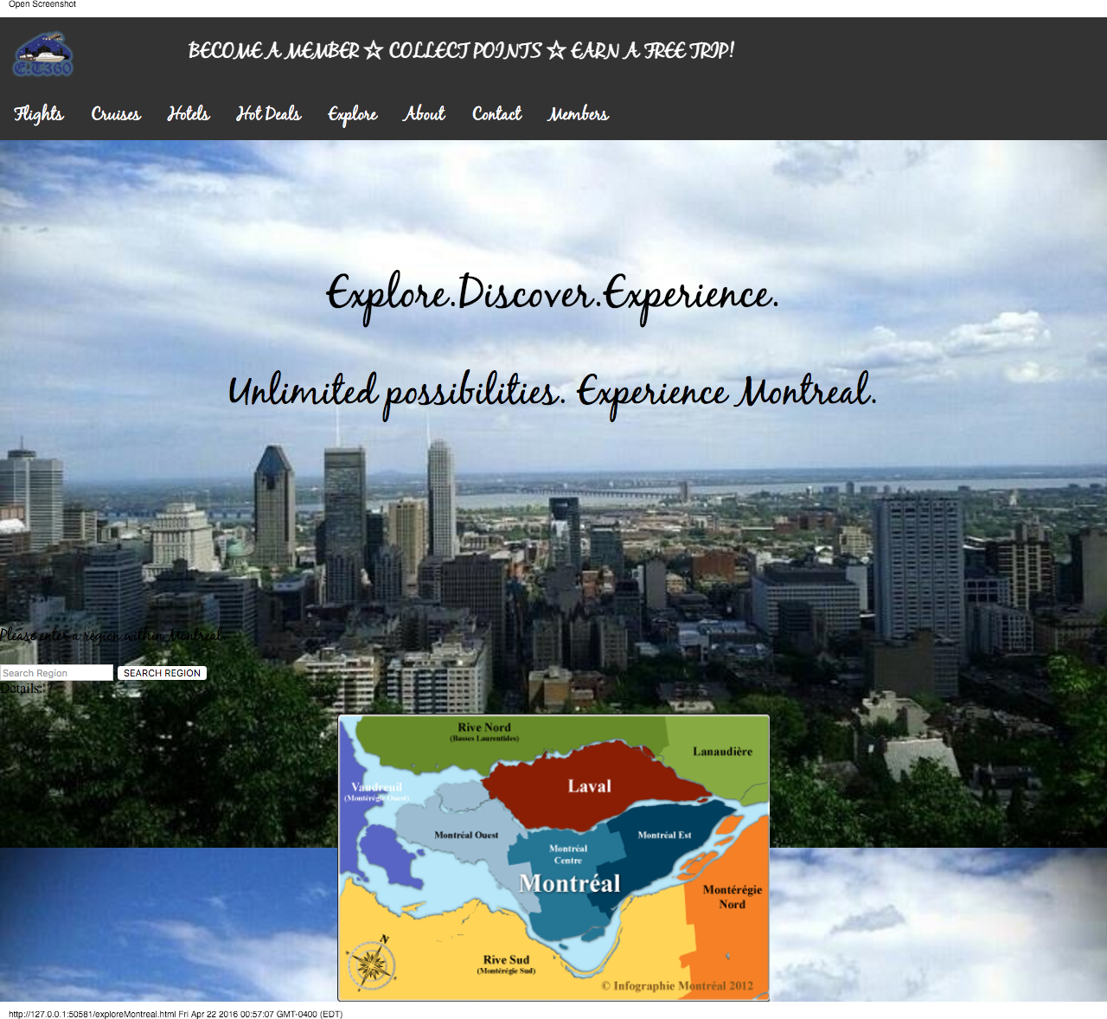

* **The following page will be redirected if the user searches Montreal West.**

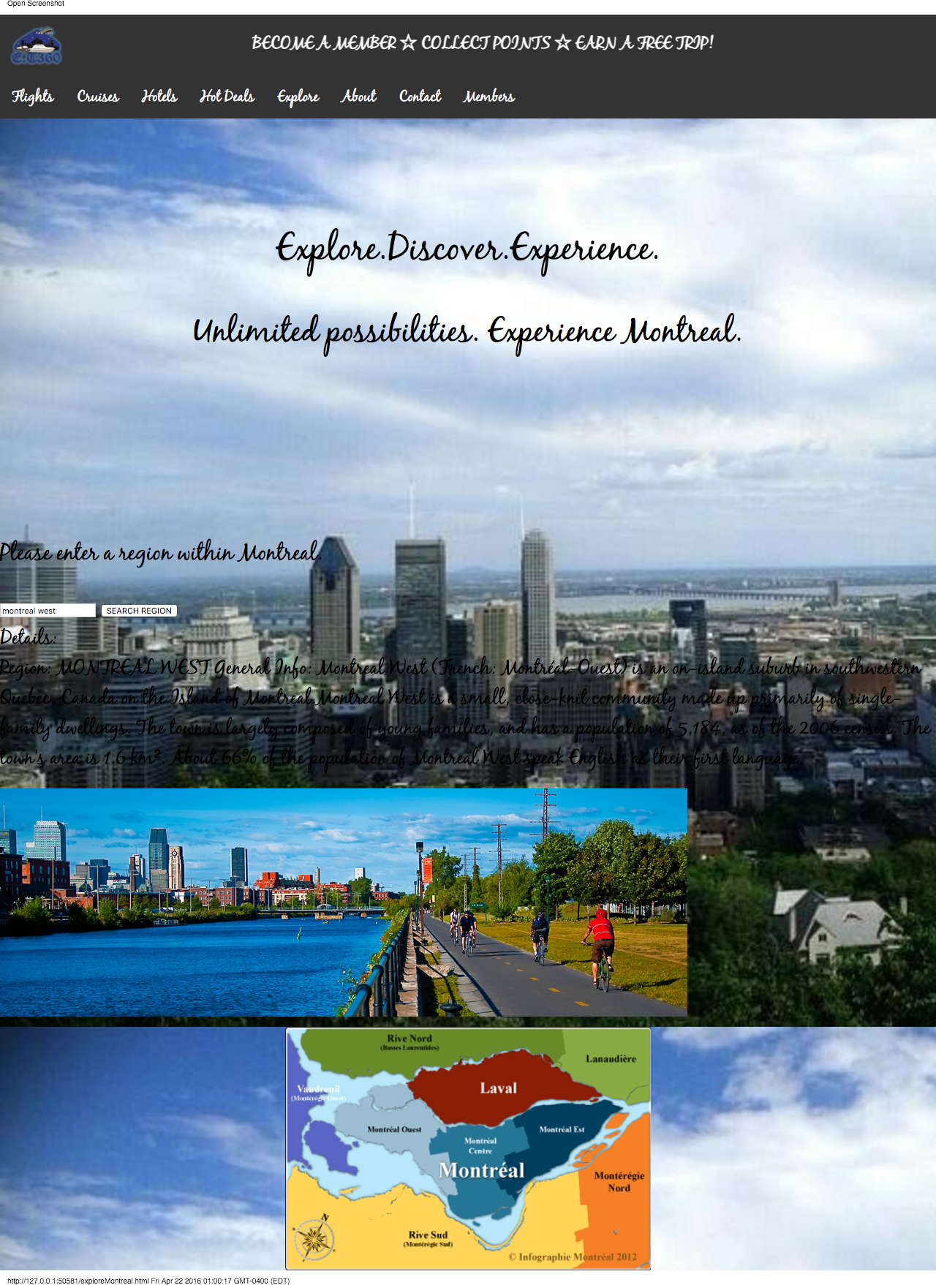

* **The following page will be redirected if the user searches Montreal.**

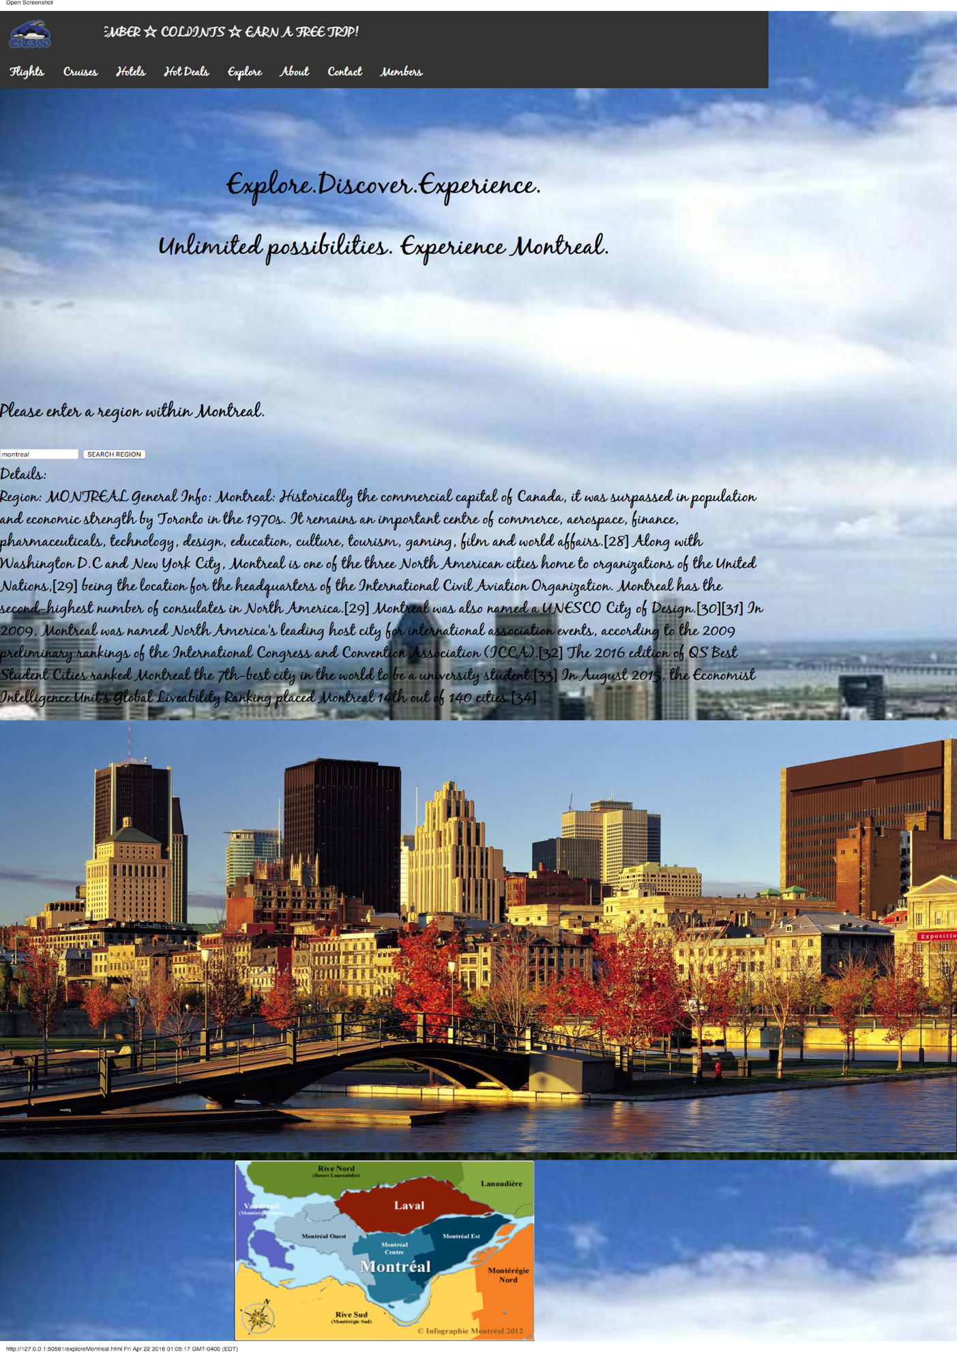

* 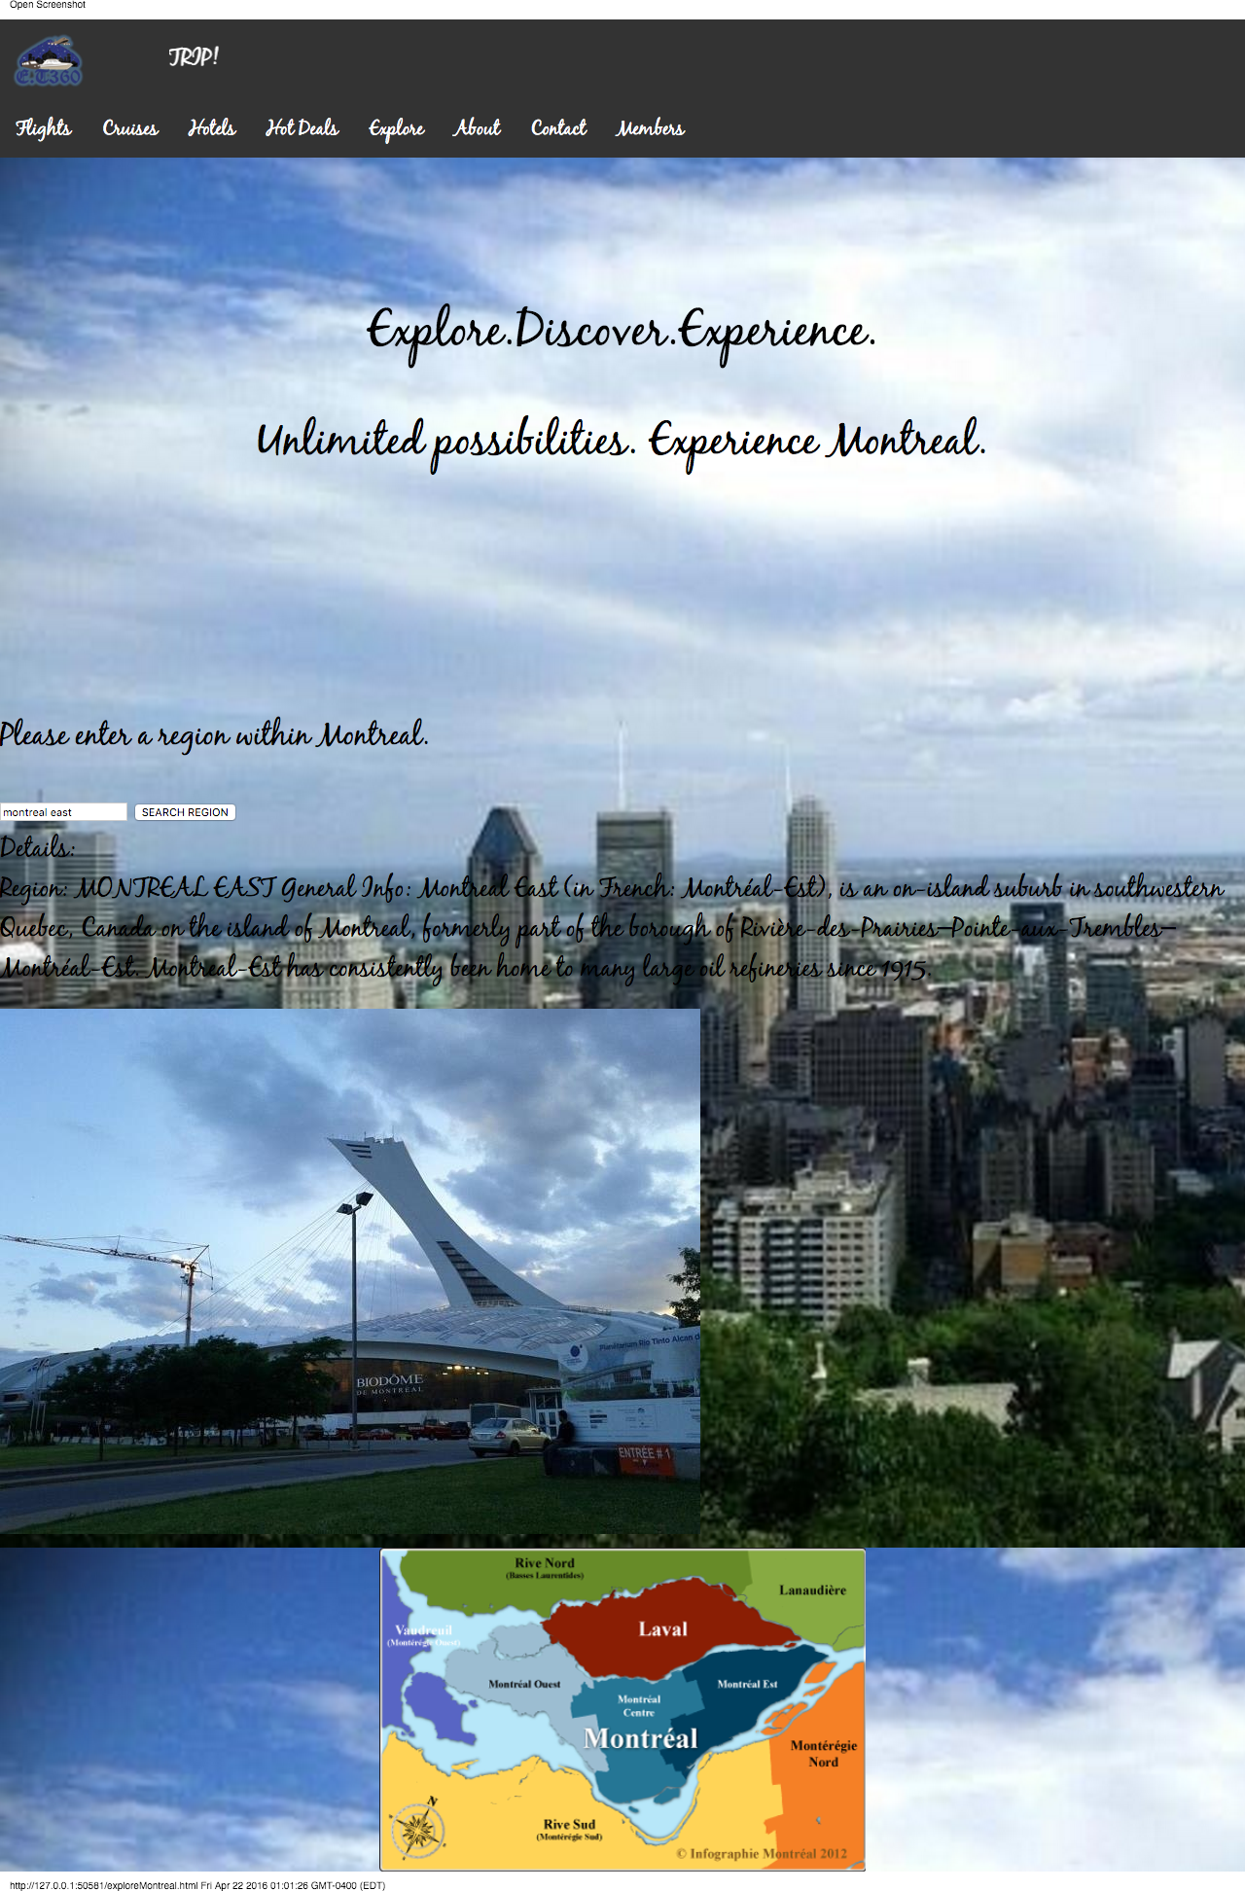**The following page will be redirected if the user searches Montreal East.**

* **Fifth Page: About Us page, containing a timeline.**

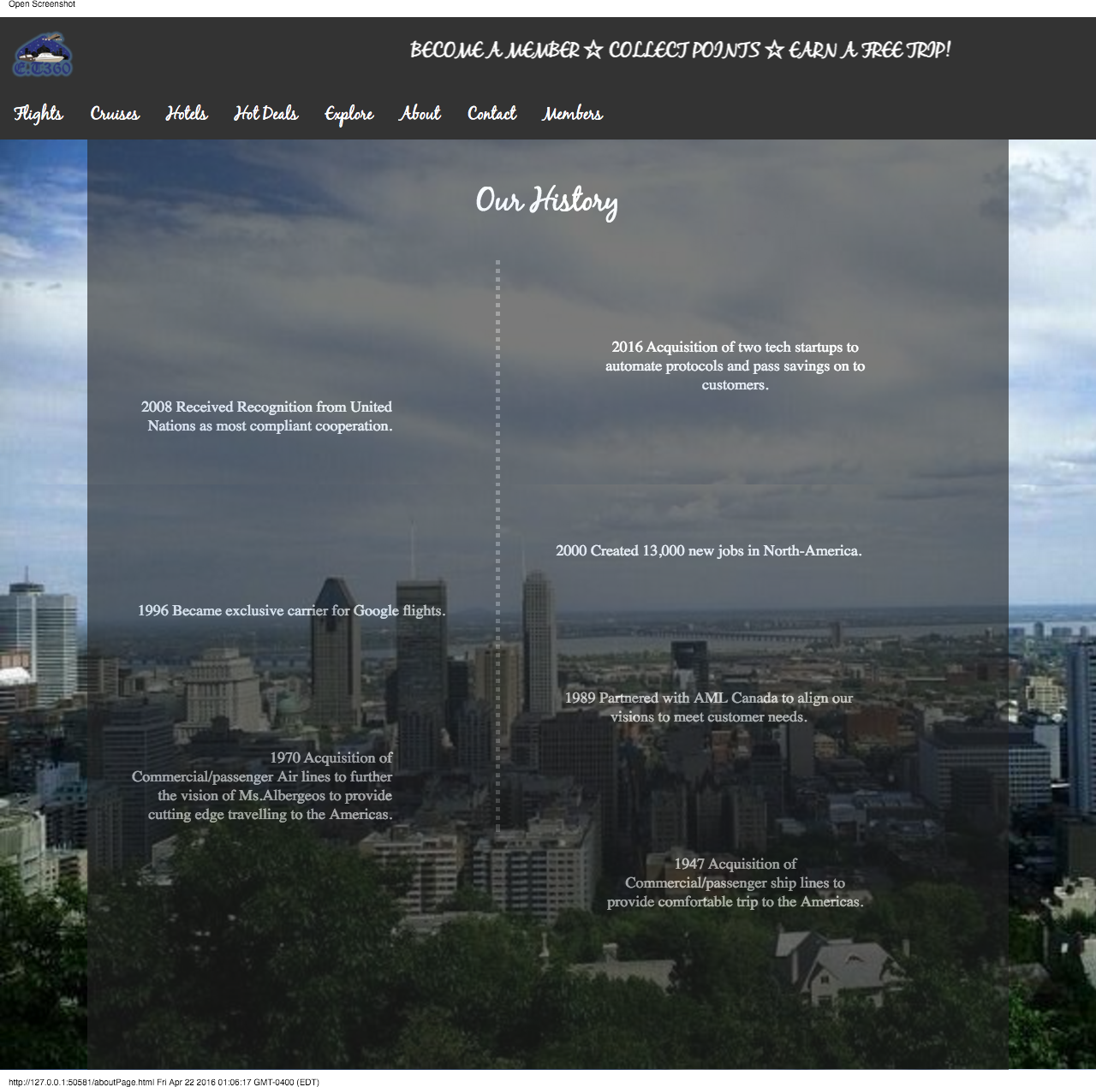

* **Sixth Page: Contact Page**

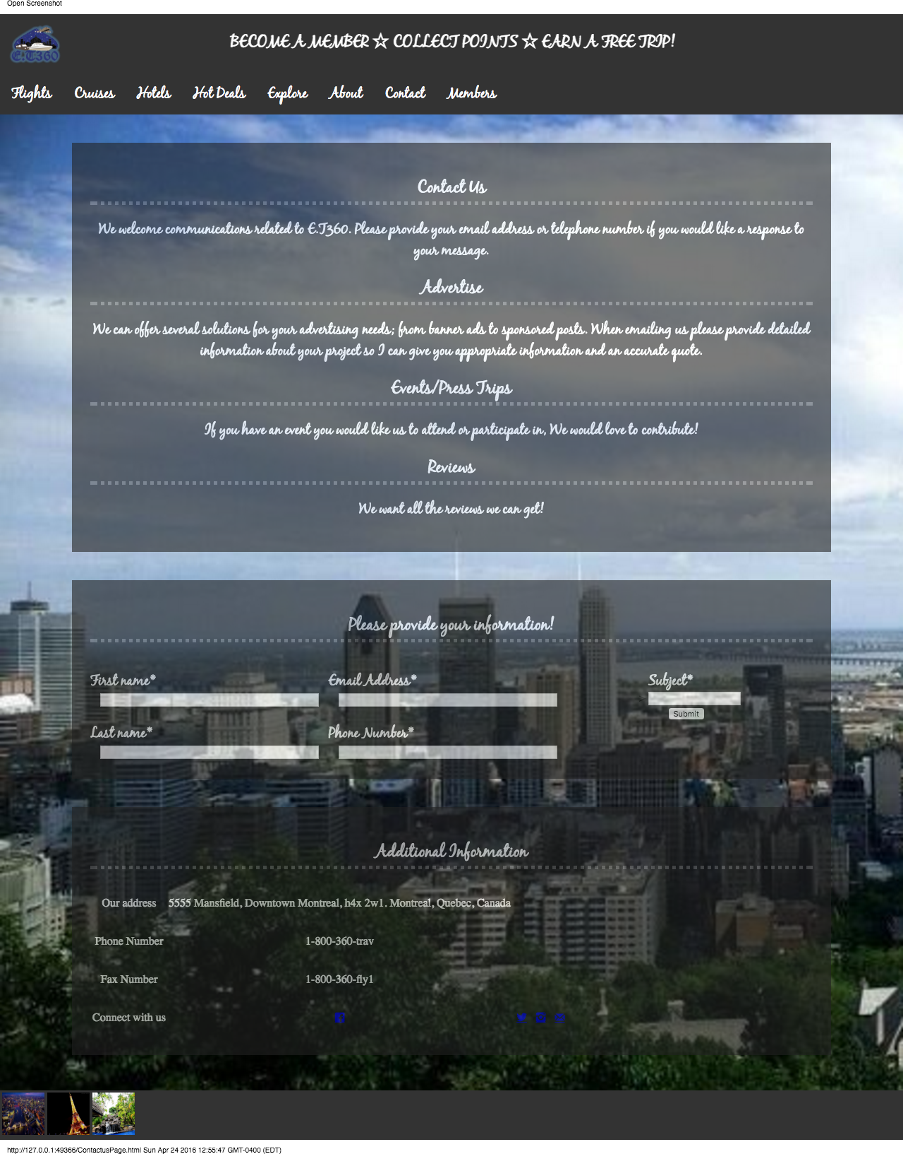

* **Seventh Page: Members sign up or Login in Page.**

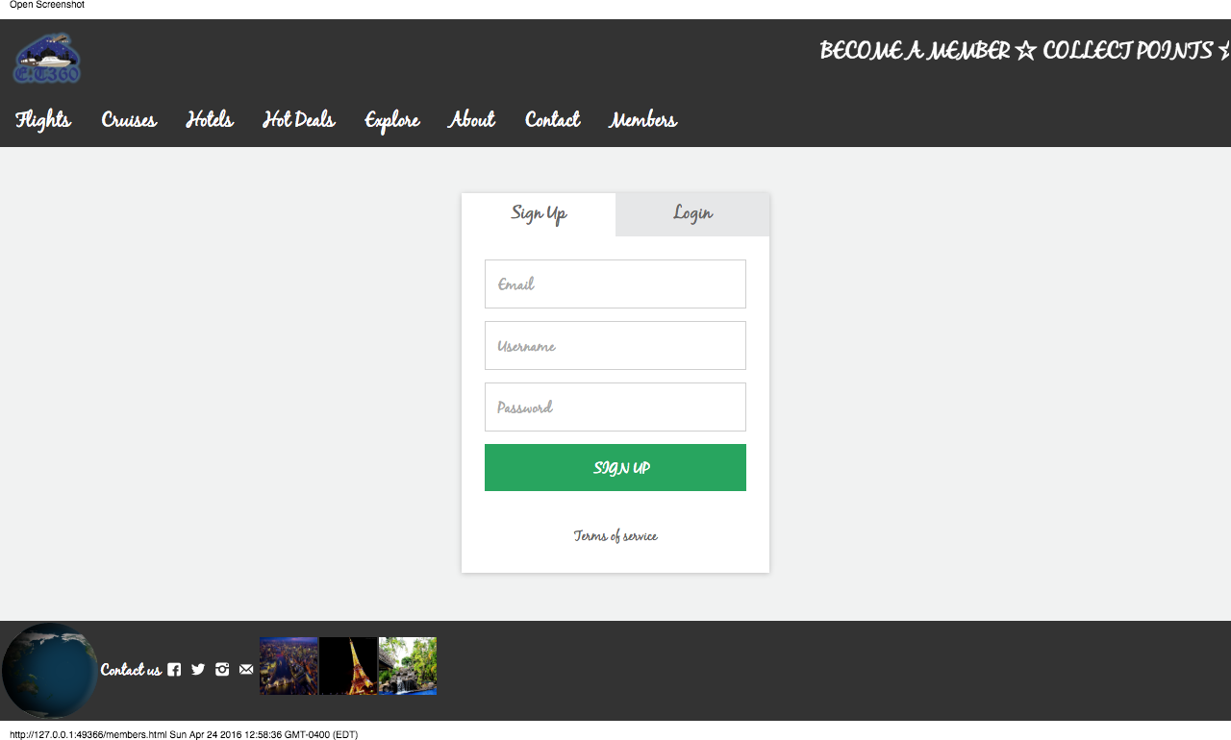

* **Under the cruise tab, once the user selects a package and clicks checkout, the following page will display.**

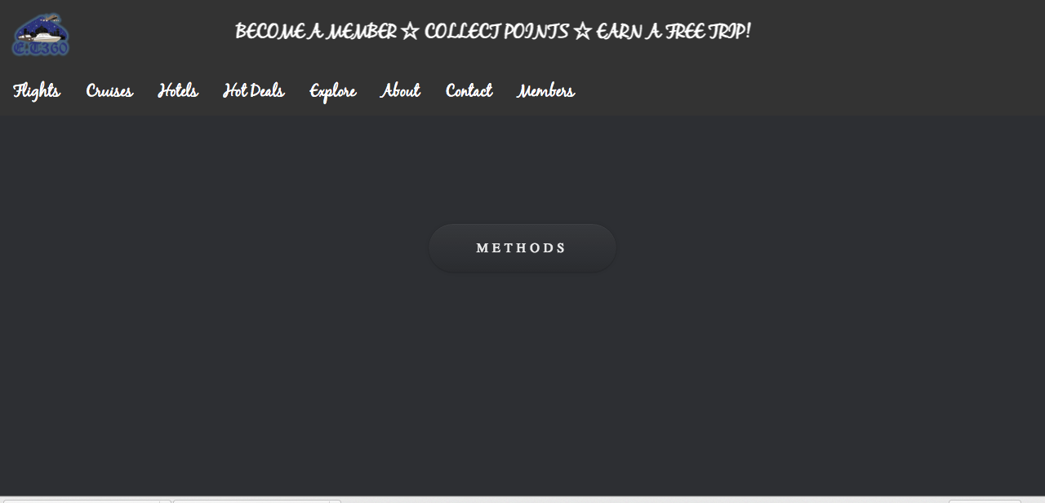

* **Once the user hovers over the methods button, the following page will display where they can select the desired method to pay for the selected purchase.**

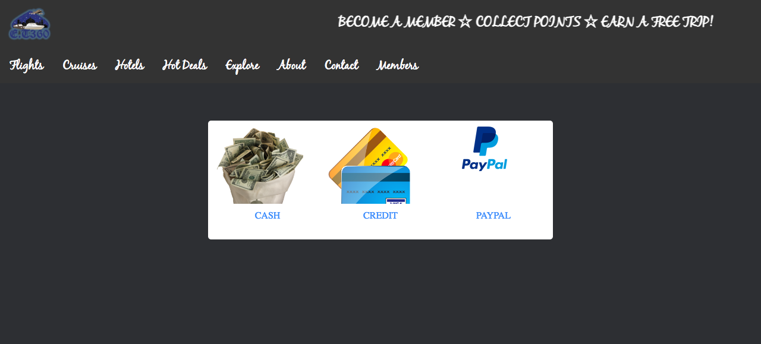

* **If the user selects cash, the following page will be displayed. Where they can insert the total amount.**

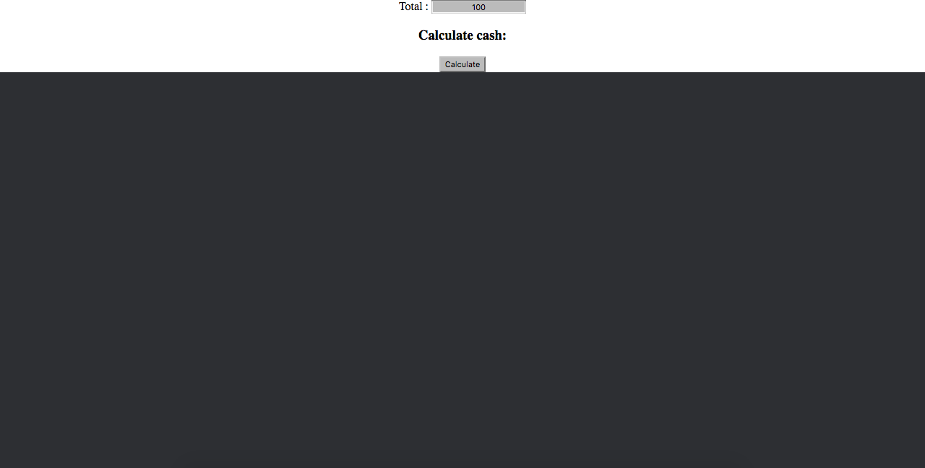

* **Upon clicking total, under calculate cash, it will display how many bills to give. (100,20,10,5) As shown in the following picture.**

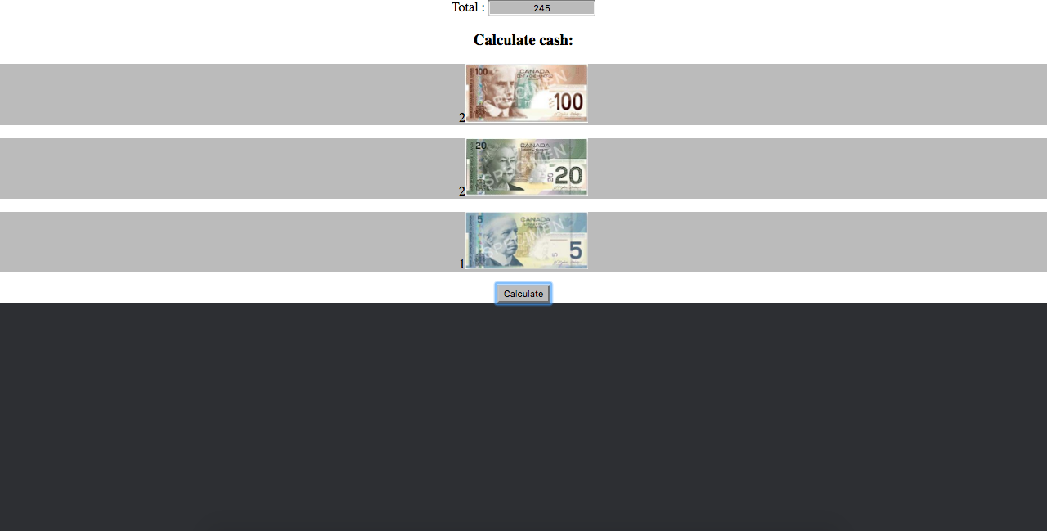

* **If the user selects credit, the following form will be displayed in order to enter their information.**
* **If the user selects PayPal as a form of payment method, they will be redirected to paypal.ca.**

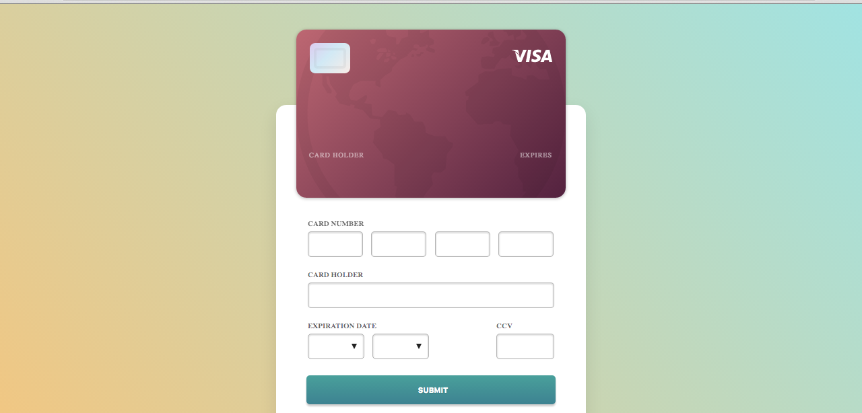

**Technical Manual:**

**Summary of each Tab**

* Main Landing Page

Welcomes User with a beautiful introductory video. Incentivize them to become member and start earning points towards a free trip !

* Flights tab

Allows User to find flights they are looking for at affordable prices !

* Cruises Tab

Has a variety of luxurious packages to choose from. An amazing experience for all.

* Explore tab

Familiarize yourself with Montreal or even the globe at large

* Contact Us Tab

Have a question , Get in touch. We are here to help !

* Our History

Who we are, what we do and what we believe in !

* Member Tab

Aren’t a member yet, sign up and earn points today !

**Functionality of each Tab**

* Main Landing Page

HTML Embedded Video, Divs, Tables, CSS styling, Photo Links, External links

* Flights tab

Divs, Google flights Api, CSS styling, External Links.

* Hot Deals

Divs, JS slide show animation, CSS styling.

* Cruises Tab

Tables, Divs, JavaScript, JQuery, Cookies, External Links.

* Explore tab

Internal Links, External Links, Mapping, CSS filters & Styling

* Contact Us Tab

CSS alpha transparency, CSS styling, Raw HTML, User Data Collection

* Our History

CSS styling, JS animations, Use of timers, Web Responsiveness, External Links

* Member Tab

JavaScript, CSS Styling, External Links, JS Animations

**Code Portion**

HTML files are equipped with Divs, Tables,Ul/Ol. Classes & Ids are used for styling and for linking (Eternal/Internal).

**In CSS, properties like**

Margin 🡪 Spacing purposes

Padding 🡪 Spacing purposes

background-image 🡪 Sets background image

background-repeat 🡪 Set if images repeats or not

background-size🡪 Size of image

text-align 🡪 Aligns Text

color 🡪 Color of text

font-family 🡪 Font of text

font-size 🡪 Font Size

letter-spacing 🡪 Spacing between letters

text-transform 🡪 Make text upper/lower case

height 🡪 Sets height

width 🡪 Sets width

display 🡪 Ul/Ol Styling

list-style 🡪 Ul/Ol Styling

|  |  |  |
| --- | --- | --- |
| FUNCTION | CODE | DESCRIPTION |
| $(window).scroll(function() |  | This function is used in website on our history page to add Animation when user scrolls. |
| function findCity() {} |  | This method is used in in website in our Explore page. It uses a switch to help user search for Continents. |
| $(window).scroll(function(){} |  | This method is used in in website in our Home page to allow for a dynamic background image. We alter padding/margin in here. |
| function loginmenu(){} |  | This method is used in in website in our Login screen to validate credentials. We accept admin & 1234. |
|  |  |  |
|  |  |  |
|  |  |  |

**Main JavaScript Function**

REQUIREMENTS

* COOKIES
* REGEX (VALIDATION)
* MAPPING
* CACHE
* SEARCH BAR
* INTERNAL/ETERNAL HTML
* CSS (PROPERTIES)
* HTML (DIV/TABLES)
* MONEY DISPLAY

BONUS

* JS SCROLL ANIMATION
* JS CART ANIMATION
* JS PAYMENT ANIMATION
* EXTRA PAGES
* MORE FUNCTIONS
* VIDEO & AUDIO EMBEDDED
* SEARCH AUTOCOMPLETION
* SLIDESHOW ANIMATION